Chapter 1: Equations and Inequalities
1.8 Other Types of Inequalities
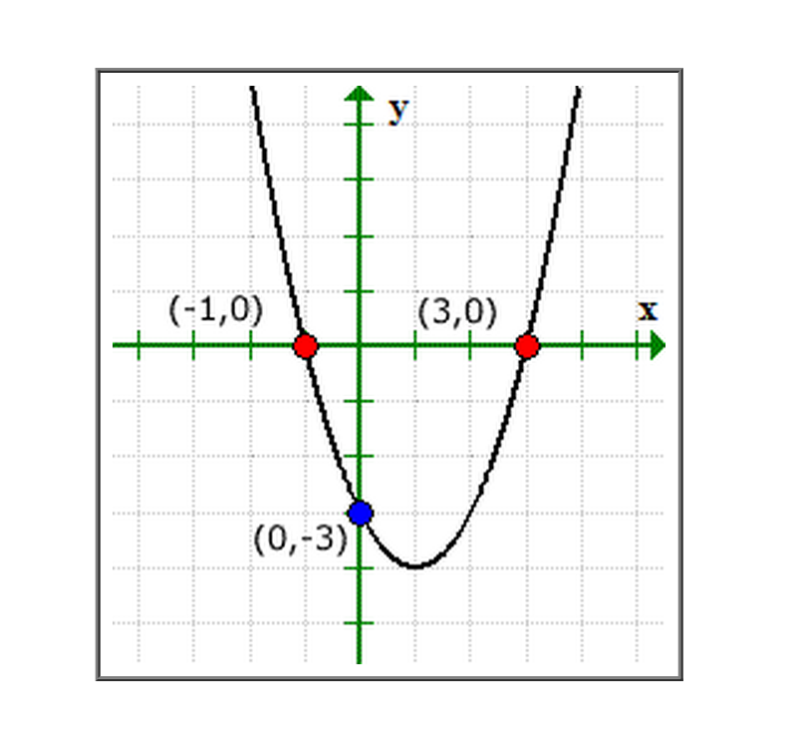
To solve a polynomial inequality such as ${ x}^{2}-2x-3<0$ you can use the fact that a polynomial can change signs only at its zeros (x-values that make the polynomial = to zero).

Between two consecutive zeroes a polynomial must be entirely positive or entirely negative. These zeros are the critical numbers of the inequality, and the resulting intervals are the test intervals for the inequality.
$x^{2}-2x-3=(x+1)(x-3)$
The polynomial above has two zeros, $x=-1$ and $x=3$, and these zeros divide the real number line into three test intervals:
3
-1
$\left(-∞, -1\right), \left(-1, 3\right), and (3, ∞)$

-----------------------------------------------------------------------------------------------------------------------------
SOLVING A POLYNOMIAL INEQUALITY
1. $x^{2}-x-6<0$ Standard Form
( )( ) = 0 Factor

Critical Numbers

Test

Interval Notation

2. $x^{2}+4x+4>9$ 3. $2x^{2}+5x≥12$

4. $9x^{3}-25x^{2}≤0$ 5. ${(x-3)}^{2}<1$

6. $3x^{3}+x^{2}-24x>-8$ 7. $2x^{4}-3x^{2}-20 ≤0$

SOLVING RATIONAL INEQUALITIES
The concepts of critical numbers and test intervals can be extended to rational inequalities.
The value of a rational expression can change sign only at its zeros (the x-values for which its numerator is zero) and its undefined values (the x-values for which its denominator is zero).
These two types of numbers make up the critical numbers of a rational inequality.

8. $\frac{x-4}{x+5}<4$ 9. $3+ \frac{3}{x-5}>x$

10. $\frac{2x-7}{x-5}≤3$ 11. $\frac{x^{2}-2x-15}{x-2}≥0$

